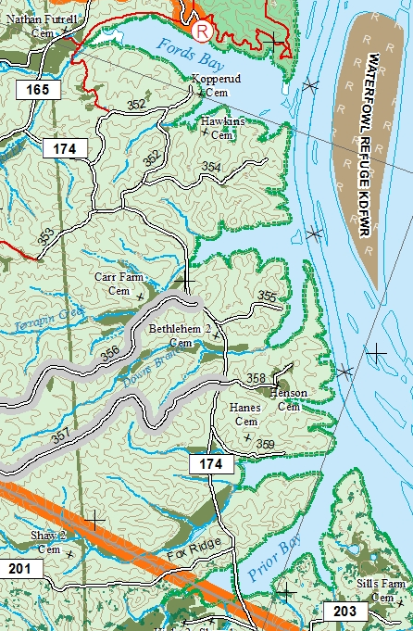
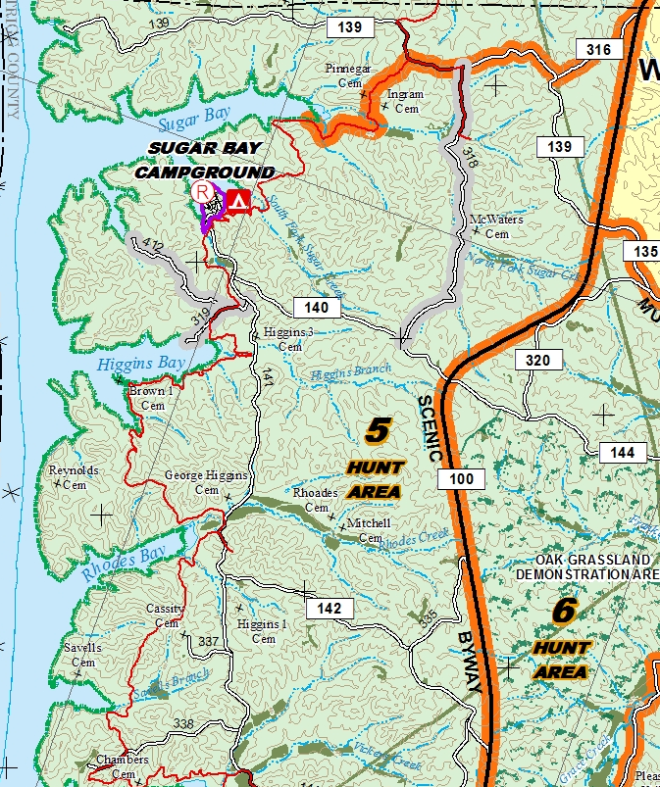
Ford’s Bay camping trip to Lake Barkley with options on Kentucky Lake
May 12-14 (***May 14th is Mother’s Day. Be Warned!!)
We will meet at 6am at the Cracker Barrel restaurant at Brooks Kentucky, just off I-65.

The Group
John Nelson
John Hamlet
Tim Aebly
Todd Elder
Henry Day (Eddie’s 11-year-old nephew)
Eddie Muns
Transportation – 3 vehicles
Nelson carrying his canoe (must drive separately since returning Saturday). Nelson and Todd riding. Todd rides home with Eddie.
Eddie carrying one canoe and Todd’s kayak. Eddie and Henry riding.
Tim carrying his and Hamlet’s kayaks. Tim & Hamlet riding.

Tents
Eddie & Hamlet will bring group tents.

Food
Tim will bring a propane fryer.
Eddie will bring all other dinner items (fish fry, hushpuppies, potatoes for French fries, bagged salads, cooking oil, water, dishwashing stuff, salt & pepper).
Eddie will bring a french press coffee pot, pot for boiling the water, and coffee for all.

Each camper is responsible for…
Their breakfasts and lunches
A cup/coffee mug, plate and utensils
Bedding (sleeping bag and pad)
Flashlight
Sunscreen
Umm… a trowel and toilet paper
Any other personal items (beverages, books, etc.)

Before the trip, you MUST buy a backcountry three-day permit. See the link below in the Camping section

Camping
We will camp in the area of the Ford’s Bay boat ramp (R in a circle on Ford’s Bay map). If this site is occupied, we will drive to Higgins (where the road ends in the water), Sugar, or Rhodes.

Everyone over 18 needs a Basic Camping permit. The 3-day permit will be perfect. It’s $7. Go to https://www.usedirect.com/CampLBL/ or www.landbetweenthelakes.us and click on Reservations & Permits.

Backcountry camping: no drinking or dishwashing water, no toilets. Nearest toilet will be 5-10 minutes by car at Wranglers Campground (or closer if you bring a trowel).

Meals
The plan is to have group dinners only. Breakfasts and lunches will likely be on the water. We plan to have fish meals both Friday and Saturday nights.

Food limiter = no electricity, no water

Fishing
For bass: All your typical baits – green soft plastics (worms, craws, lizards usually Texas rigged because there will be a bunch of down trees in the water we fish, though Shakyhead works where trees are sparser), jig-and-pig/craw, crankbaits in shad or silver colors, Rattletraps & Redeye Shads. Typical depths fished 1-20 feet.

For bluegills: All your typical baits – flies, live bait, beetle spins, small crankbaits, inline spinnerbaits. They should be nesting this time of the year, so sight-fishing is likely!

The Water
Lake Barkley
Ford’s Bay:
- There’s a shallow channel all along the side by the boat ramp. This fishing can be good at times.
- The best fishing is often the north side of the mouth of the bay, where baitfish will school and LM/white bass will feed heavily. Wind often would prevent a kayak from fishing this area, and this area can have big waves due to wind, boats and barges.
- The south side of the bay is pretty magical. It has good deep water access (20 foot +) along all three of the main cuts and lots of downed trees. Bass fishing is often very good, and it’s excellent habitat for panfish as well.

Moving from bay to bay: Barkley is a very dangerous lake due to extremely shallow spots. All boats will stay within the channel markers. Kayaks and canoes will be able to safely paddle the shallow areas close to the bank.

One larger main-lake cut between Ford’s and Terrapin: this heavily wooded cut has surprisingly deep water through much of it. Because it’s pretty small, and not easy to get into with the shallow water, it’s rarely fished.

Terrapin Bay:
- The large, south-directed arm of Terrapin is excellent and extends from deep water-to-shallow-structure toward the mouth, to shallow water with downed trees in the back of the arm. This is one of our go-to spots, often catching smallies on crankbaits in the first third, then LM around the timber in the rest of the arm. The entire end is a shallow bowl that could fill with bluegill nests.
- There is a point ledge extending from the corner separating the south-directed arm from the main bay. The ledge extends toward the mouth from the main bay bank.
- This is a great bay for fishing shallow wood or sight-fishing for panfish.

Kentucky Lake
Many great options if you are willing to drive the backroads and portage to bays on KY Lake. All roads are open that time of the year. Rules say that you must park entirely off the road.
- Sugar Bay’s Five Fingers (first south cut off the main lake) is the best area and is very protected from wind.
- Other great bays: Small cut between Sugar and Duncan, Savel’s Branch (probably hard to get to), Rhodes (shallows, south side of bay especially point of small cut and bank leading toward mouth), Higgins (shallows, south-facing arm, south-side of main bay), Duncan, Sugar Bay in the shallow back water, Vickers.

The Wind
Prevailing wind is south-southwest. All Lake Barkley areas mentioned are protected from most wind due to direction and because it’s a fairly thin river along this section. Sugar Bay’s Five Fingers cut is protected from most wind. Pay attention to wind speed and direction if going to other bodies of water. Higgins has good protection due to a narrow mouth and plenty of good fishing water on the south side.

