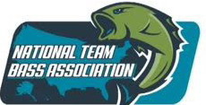
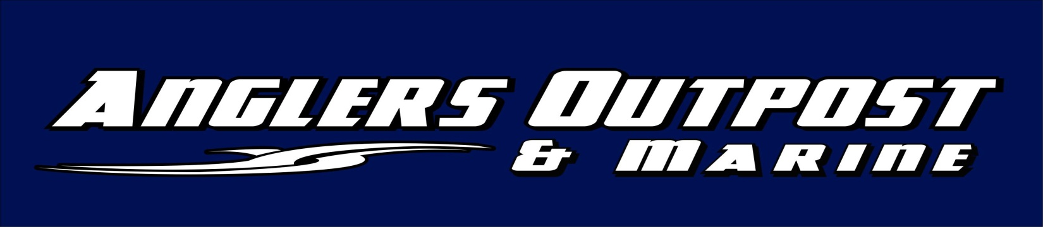

Where the average Fisherman has a chance to qualify for
The 2019 BASS MASTERS CLASSIC
Win $10,000.00 at Barren River Lake with 100 boats
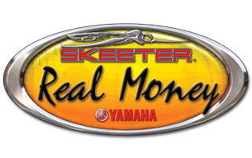
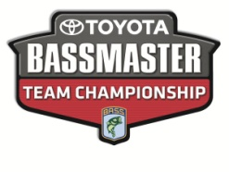
$5,000.00 Guaranteed by Anglers Outpost, Skeeter Boats, and Yamaha Motors
CLASSIC October, 12 & 13 2018
Port Oliver Ramp
All Tournaments qualifies for Skeeter Real Money
Membership $60.00 Entry $80.00 includes Big Fish
Must fish just 3 tournaments to qualify for Fall
Classic 1st Place $10,000.00 and
Anglers Outpost NTBA Skeeter Invitational to fish for 1st Place $10,000.00 Spring 2019, lake to be announced at Classic 2018 and a chance to fish the Bass Master Classic in 2019, Flag Circuit will pay 1 place for every 7 teams
#9 Flag Circuit
Date Time Lake Ramp
March 10 6:30-2:30 Rough River State
March 31 6:30-2:30 Nolin Moutardier April 14 6:00-2:00 Rough River State
April 28 6:00-2:00 Nolin Moutardier
May 12 6:00-2:00 Rough River State
May 26 6:00-2:00 Nolin Moutardier
June 16( Make update If Needed) Rough River State

Dale Fleenor 270-668-5224 and Eric Braden 270-319-6767 All times EASTERN time
CLIFFORDS
FIBERGLASS
PAINT, REPAIR & SUPPLIES
Boats,RVS, CARS,TRUCKS & TRAILERS
4432 Popular Level Rd
Louisville Ky. 40123
Tel. (800)367-7451 or 502-451-5400
www.cliffordsinc.com Email pcliffotd@bellsouth.net

