2nd Annual
MCHS Fishing Team
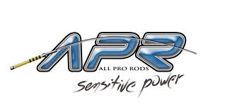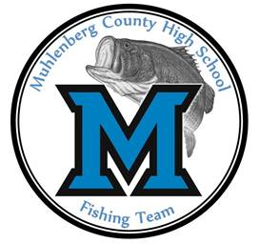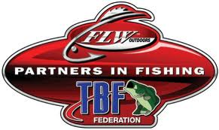

SWAP MEET 
Saturday January 25th 2014
Muhlenberg County High School West Campus
Time: 7:30am – 2:00pm
Open To The Public
All Proceeds Go To The Mustang Fishing Team
Admission At Door: Adults-$5.00 Children-12 & Younger-Free
SWAP – BUY – SELL – TRADE
100 Tables Available So Book As Soon As Possible
$15 for the first table and each table after that is $10
All Fisherman bring tackle and accessories
Anything that is Fishing Related
(No Guns Allowed!!!)
- All Dealer & Vendors need to enter the gym door #2 (Set up starts at 6:00am)
- Dealers please keep your booths set up until 2:00pm
- Public please enter the gym door #1 (Doors open at 7:30am)
- Used Boats can be displayed at this event (Contact Cody Napier before bring boat)
- Food and refreshments are available
- Muhlenberg County Fishing Team is not responsible for any accidents or theft
- Raffling off an ALL PRO ROD
- $3 for one and $5 for 2 tickets drawing takes place at 1:30pm, need not be present to win
- NO SMOKING IN SCHOOL!
Contact Information: Head Coach Cody Napier- 270-977-7461
Email: cody.napier968@topper.wku.edu

