Carrollton’s Two Rivers
Bass Tournament
Sponsored by Carrollton/Carroll County Tourism
Oct.11th 7am-4pm & Oct. 12th 7am-3pm
at Point Park in Carrollton, Ky.
$150 entry fee for 2 Person Team
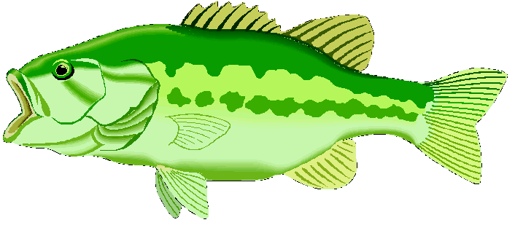
$5000 Guarantee
Registration forms are available on line at www.visitcarrolltonky.com or in the Carrollton/Carroll County Tourism Office at 515 Highland Ave.

$250 Big Bass Award Each Day by


Pretournament meeting Sat, Oct 11th at 6am
Door Prizes ….Polygraph administered ….
Kid’s Fishing Tourney & activities
Sun., Oct 12th at11am by Ky Dept of Fish & Wildlife.
For more information contact,
Misty Wheeler, Executive Director, Carrollton/Carroll Co Tourism
director@carrolltontourism.com
www.visitcarrolltontourism.com
502-732-7036

