Anglers Outpost & Marine’s
NTBA



Kentucky Lake Classic
Where the average Fisherman has a chance to qualify for
BASS MASTERS CLASSIC
Win $10,000.00 at Kentucky Lake with 100 boats

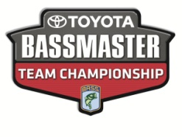
$5,000.00 Guaranteed by Anglers Outpost, Skeeter Boats, and Yamaha Motors
October 2 & 3, 2015
Kentucky Dam Marina
All Tournaments are Skeeter Real Money qualified
Membership $60.00 Entry $50.00 Big fish $10.00
Must fish just 3 tournaments to qualify for Classic
Director Tracy Phillips 502-319-2487
#6 Taylorsville
Date Time Ramp
April 25 Safe light to 2:00 P.M. Possum Ridge
May 24 Safe Light to 2:00 P.M. Possum Ridge
May 30 Safe Light to 2:00 P.M. Possum Ridge
June 13 Safe Light to 2:00 P.M. Possum Ridge
June 21 Safe Light to 2:00 P.M. Possum Ridge
July 12 Safe Light to 2:00 P.M. Possum Ridge
Director Tracy Phillips 502-319-2487

To get your business logo here or on our web page
Contact Mike Combs at 859-619-1111 hmcgonefishing@gmail.com
Anglers Outpost & Marine Ph. 859-881-5266
96 Camp Dick Rd. Fax 859-881-9735
Lancaster, KY 40444 anglersoutpost.com

